W2 IDE Overview & Reference Manual

This manual is designed to give you a quick summary of the functionality of the W2 environment, as well as a more comprehensive reference of all the features available.

Use the index to the right to quickly find the area of the designer you wish to look at. A number of chapters are repeated firstly in overview form, and then as a reference. The overview will give a simple idea of what that part of the designer is about, but will not go into any detail. The reference section will explain what every edit box and text label is about.

This manual does not attempt to teach you how to program in W2; it simply attempts to explain the designer interface. The separate document ‘W2 How To’ does more to show you how to perform specific tasks using the W2 designer in an efficient way.
Overview of W2 IDE 2
W2 Designer 2
W2 Browser / W2 Help 2
W2 Project 2
W2 Wrapper 2
W2 Find In Files 2
Opening the IDE 3
Closing the IDE 3
W2 Designer (Overview) 4
Class Hierarchy Pane 4
Class Toolbar 5
Class Editing Pane 6
Designer Menu 6
W2 Designer (Reference) 7
Class Definition 7
Member Section 10
Member Variable Definitions 11
Member Function Definitions 13
Method Editor 14
Form Template 15
Form Menu 18
Hierarchy Display 19
Designer Menu Reference 20
W2 Browser (Overview) 22
Using the Browser 22
The Browser Help System 22
Searching in the Browser Help System 22
W2 Project (Overview) 23
Manipulating the class structure within a project 23
W2 Wrapper (Overview) 24
W2 Find in Files (Overview) 25
Appendix: Control Edit Floating Toolbar 26
Grid 26
Label 27
Image 28
Edit 28
Radio 29
Checkbox 29
PickQuery 29
ListBox 30
Hierarchy 31
Component 31
MultiPane 31
SizeBar 31
MapEditor 32
SourceEditor 32
RTFEditor 32
ImageViewer 32
Custom Attributes 32

Overview of W2 IDE

This is a quick overview of the main screens of the W2 Integrated Development Environment. A short description and screenshot has been provided for each, and a reference to the page number on which you will find more in-depth information.

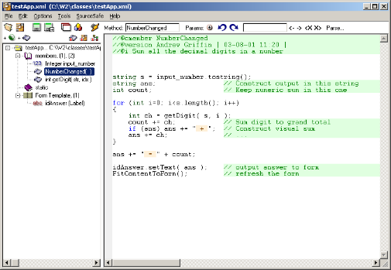
W2 Designer
This is the main window for creating & manipulating W2 classes & their code & form templates. From here you will do all your coding and development, building applications and launching the other W2 IDE tools. A separate W2 Designer window is launched for every class you open in a session (unlike all other W2 tools that only open in a single window).

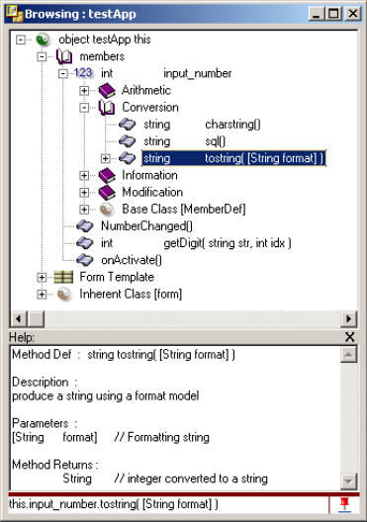
W2 Browser / W2 Help
The Browser displays classes in a hierarchy tree, listing methods & members, form controls and w2 built-ins. Classes are displayed recursively and can be opened to your desired depth of interest. When an object is browsed from the designer, the browse path will be opened for you. The Browser is also used as a W2 class help system showing the available built in classes & methods.

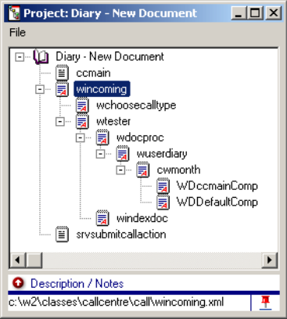
W2 Project
A Project collects together classes you require for a specific programming task. The project is again hierarchical so you can place one class as the child of another, just as it would be when the classes in question are executing. Project provide you with quick access to the classes you are working on, allow other programmers to quickly approach your code with a better overall view, and add extra functionality to the Browser and form template view.

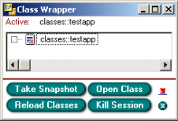
W2 Wrapper
W2 Wrapper takes snapshots of running code, letting you see what classes are used where and allowing you to quickly open them. Projects can also be generated from a running instance to get you to the developing stage faster.

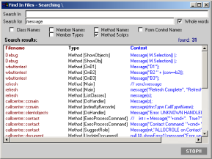
W2 Find In Files
Find in Files is a W2 class specific search tool for finding textual occurrences in class, method, member & control names as well as the actual W2 code itself. Once a search has been done you can jump directly to the occurrences in the W2 Designer with a simple double click of the mouse.

Opening the IDE
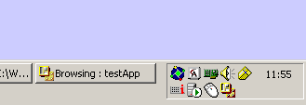
W2 IDE Toolbar Icon
The W2 designer IDE interface can be loaded in a number of ways. Once open, it remains open (even when all windows have been closed) as an icon on the taskbar (See right).

If the IDE is not yet open (no icon on the taskbar) and you open any of the following applications, the IDE is launched, and the corresponding actions will take place.

- W2 Designer - Opens a fresh Designer window
- W2 Browser - Pops up the Browser window
- W2 Project - Pops up the Project window
- W2 Wrapper - Pops up the Wrapper window

The same is true for the following file types:

- *.XML - Opens the XML file in it’s own designer window*
- *.XPJ - Opens the Project file in the project window

* Note: If the XML class file is already open, a new copy will not be opened. Instead the focus will return to the existing instance of the class in the open window.

Closing the IDE

As stated above, the IDE stays open (even when all other windows have been closed) as a simple icon on your taskbar. There are a number of levels of closure you can perform on the IDE. You access these options by clicking on the IDE taskbar icon, or from the File menu from a designer window:

- Close - Close the current designer window
- Close All - Close all open designer windows
- Close IDE - Close all designer windows, browser, project & IDE

You will of course be prompted to save any unsaved document or projects before the windows are closed. You also have the option to cancel the close if you change your mind when informed that a class is unsaved.

W2 Designer (Overview)

A W2 designer window (see right) is a container holding a single W2-class ready for editing. A separate designer window is opened for each class being edited. The window is split into two vertical panes. The left pane shows a hierarchical view of the open class, while the right pane is used to edit the selected part of the class hierarchy (highlighted in blue). Above each of the panes is a toolbar, and above those, the menu bar.

Class Hierarchy Pane

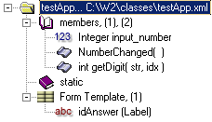
The left hand side of the designer window is dedicated to the class hierarchy pane. This pane shows a hierarchical (pictorial) view of the class currently open in the designer window. When the user selects a row, the right hand pane (editor pane) of the w2 designer window changes to the appropriate form for editing that selected part of the class.
Class Definition: The whole class hangs from this small folder at the top of the class hierarchy. ‘testApp’ is the name of the open class, and ‘C:\W2\classes\testApp.xml’ is where it is located on a particular storage medium. When selected, the editing pane of the designer changes to allow you to edit the class definition (including base class name, Database Options & Form displaying options).
Class Sections: A W2 class, akin to a C++ class or java class, can contain static & non-static members (members are variables and functions). The non-static members are located under the ‘members’ section, and static members under the ‘static’ section. The numbers “(1), (2)” after the members section represent a count of members & methods respectively within that section. You can add members to a class section by right clicking the ‘members’ or ‘static’ section in the hierarchy and choosing ‘new member’ or ‘new method’. Left clicking a section heading causes the editor pane to display an overview of all the members in that section. Also, the members section also provides SQL code to create the class as a database table.
Member Variables: Located within, and created from the ‘class sections’, Member variables can be of type ‘String’, ‘Integer’, ‘Double’, ‘Date’, ‘Object’ & ‘List’. When left clicked, the editor pane displays all the variables attributes allowing you to edit its name, type, class, description, database options, default value, and more. Right clicking a member variable also gives you further options (i.e. to copy & paste, duplicate, delete, search, etc…).
Member Methods: Also located within and created from the ‘class sections’, Methods are where the real coding takes place. When selected, the editing pane displays the source editor and you can begin coding. Right clicking a method gives the same functionality as for member variables.
Form Template: A form class has its form attached to the Form Template section in the class hierarchy. Selecting the form template causes the right hand edit pane to show an editable version of the classes form. Also, within the form template hierarchy section is a list of the ‘named’ controls that reside in the form template. Clicking on these will select the associated control in the edit pane. You also have extra options by right clicking these named controls.

Class Toolbar

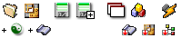
Above the class hierarchy pane is a small double row of buttons. The following is a table showing the functionality of each:

Button | Left Click | Right Click
 | Open Class from file dialog (close current)
 | New Class (close current)
 | Save Class | Source Safe Quick access (check out, in, etc…)
 | Save Class under a new name
 | New Class in new designer window
 | Browse Class (in W2 Class Browser) | Flush Browser Class (in case of sync problems)
 | Execute Class
 | Add new Member to current class section
 | Add new Method to current class section
 | Method History (last 16 viewed methods)
 | Class History (last 16 viewed classes)
 | Project History (last 8 opened projects)

Class Editing Pane
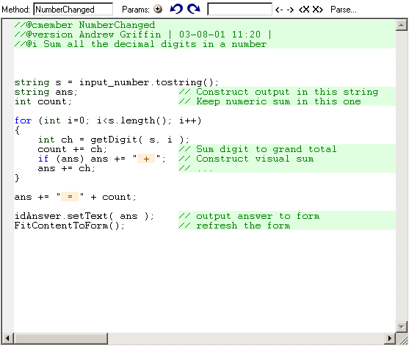
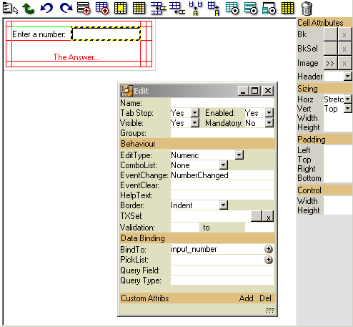
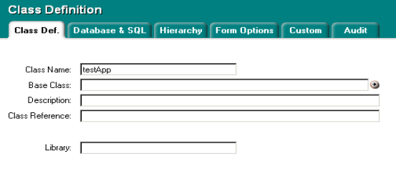
The right hand pane of the designer window is named the Class Editing Pane. Shown to the right are a few examples of what can appear in this pane. The ‘active’ editor is dependant on what is currently selected in the left hand hierarchy pane (generally highlighted in blue). If a method is selected then the method editor (right top in examples) is displayed, while selecting the form template will reveal the form template editor (top left in examples). The other example (lower right) is the class definition editor. Other available editors are the section, method, menu & hierarchy editors.

Each of these editors will be looked at in greater detail in the W2 Designer (Reference) chapter (on page 8).

Designer Menu

The main menu provides access to many of the same functions available from the hierarchy toolbar. However, there are a few other options available not otherwise accessible from anywhere else. The most important options are those for configuring the W2 designer environment to your PC system and to your own personal needs. Many useful features can be enabled, such as auto method tips, parse on save & show components (in form template).

For a detailed look at the designer menu turn to page 21.

W2 Designer (Reference)

In the following chapter we will go over the class hierarchy & editing panes in detail. Each member type of the hierarchy is broken down into three section: ‘Overview’, ‘Hierarchy Options’, & ‘Editing Pane’.

- Overview – contains a concise description of the member. A small picture showing a simple hierarchy example with the member in question selected is included here.
- Hierarchy Options – lists all the popup menu options available if you right click one of these members in the hierarchy.
- Editor Pane – Describes in detail what the edit pane will show & how it is to be used. Again, an example screen shot is included showing the edit pane in question.

Class Definition

Class Definition

The whole class hangs from this small folder at the top of the class hierarchy. ‘testApp’ is the name of the open class, and ‘C:\W2\classes\testApp.xml’ is where it is located on a particular storage medium. When selected, the editing pane of the designer changes to allow you to edit the class definition (including base class name, Database Options & Form displaying options).

Hierarchy Options

Right click the class definition in the hierarchy pane to get the following options:

- Browse Class
Opens the entire class in the class browser. (What this views is actually the last saved version of the current class. You should therefore save the class before browsing it for a completely up-to-date view.
- New Form Menu
Adds a new Form Menu to the end of the class hierarchy. This is the menu bar that will appear across the top of the window.
- New Hierarchy Display List
Adds a hierarchy display list to the class. If this class appears in a hierarchy control, then the display list determines what text is displayed next to its icon.

Editor Pane

When selected in the hierarchy, the right hand editor pane of the designer displays a form for editing class specific information broken down into six sub categories. We shall now cover each in turn:
CLASS DEF

- Class name
(Name of the class, this is the same as the filename without the '.xml' extension.
- Base Class
The class this class is derived from (blank if it is not derived from any class) of the format ‘classes::client::document’.
- Description
A one-line description of the class.
- Class Reference
Used to name the class via an external environment file. Enter a name to identify this class as the Class Reference. In the file ‘c:\w2\W2env.ini’ (where c:\w2 is replaced by the path name where your xrunapp.exe program is located). Enter a line of the style classReferenceName=“Some Caption”. When the class is executed the title ‘Some Caption’ will be used as this classes name.
- Library
Name of the dll to link the class with (i.e. ‘W2Scan’)

DATABASE & SQL

- SQL Table Name
If this class is to be filled from a database table, then enter the name of the table here.
- Data Source
The Data Source name (Used to tie this class to a specific table in a database). This is a lookup name that should match a data source name in the server’s scripts\config.ini file. The lookup line should be of the format:
GRF=DSN=LocalSQL;Description=My SQL Database;UID=testuser;PWD=testpassword;WSID=ACOMPUTER
where GRF if the Data Source Name and what follows is the connection string.
- SQL Alias
The unique SQL Alias for this table. (Used when generating SQL scripts at runtime).
- SQL Sequence
The name of the SQL Sequence for this table (used by oracle to create sequential key fields).
- SQL Join
Enter an SQL join string here to build this object from multiple database tables. Create a class for each of the tables to be joined, and then create a new class to hold the merged version and add each of the classes to merge as member objects to the new class. The SQL Join string is then created to tell the compiler how to join the member tables. Using the SQL Aliases to reference the member tables write something of the format:
‘TabAlias1.keyfield=TabAlias2.userId AND TabAlias2.keyField=TabAlias3.orderId’. A two table join would not generally have two ‘=’ like this but just one.

The lower portion of this pane displays SQL scripts to create the database tables to represent the W2 class. You may choose between SQL Server and ORACLE scripts.

HIERARCHY

- Hierarchy Image
Filename of a bitmap to be displayed if this object is a member of a hierarchy.
- Hierarchy Image Field
The name of a string member within the class that holds the filename of the icon to be used as above.

FORM OPTIONS

- Caption
The text that will appear in the title bar of the window if this class executed and has a form.
- Save Position As
A unique string to save the window position of this class (if displayed in that form). Once reopened after that it will take on its previous open state.
- Icon
The filename of an icon file to use as this applications windows icon when executing.
- Background Image
Filename of a bit map image to appear behind the form.
- Background Color
The colour of the background form.
- Sizeable
Is the form sizeable by the user at run time (default Yes)
- Accept Files
Does not appear to do anything.
- No Mouse Activate
This does not appear to do anything.
- Thin Frame
When Sizeable is set to No, Thin frame set to yes will make the border of the window a one pixel wide black rectangle.
- No Caption
Removes the caption bar from the top of the window (Note: you must call a window resize method on the form before it will be properly visible with this option set to yes).
- Margins
Number of pixels between the border of the window and the form within.
- Tool Window
Makes the window caption bar thinner with a little icon to close it
- Initially Hidden
When initialised, the window is hidden (does not even appear on the taskbar).
- Topmost Window
Always appears in front of other windows that are not set to be top most.
- On Deactivate
When the window looses focus, it can either stay as it is, be closed completely or just hidden.
- Close on Escape
Causes the windows to close if the ‘escape key’ is pressed.

CUSTOM

From here you may add custom attributes to the open class. These can be read using the classdef method GetAttr( attribute_Name ). Simply click on an existing attribute name or value to edit it or click the new / delete buttons to add and remove attributes from the list.

AUDIT

- Author
The name of the last user to modify this class file. (This field is automatically updated by source safe)
- Date
The date the class was last modified (Updated by Source Safe).
- Revision
The revision number of this class (Updated by Source Safe).

The lower portion of the pane displays a history of method edits (taken from the method version tags in the class). The list is sorted by date with the most recent change at the top. Double clicking a record in this list takes you to the method in question. You can use this to quickly access the most recently modified methods, or to see who has been working on a class & what they changed.

Member Section

Member Section

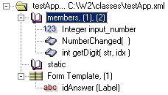
A W2 class, akin to a C++ class or java class, can contain static & non-static members (members are variables and functions). The non-static members are located under the ‘members’ section, and static members under the ‘static’ section. The numbers “(1), (2)” after the members section represent a count of members & methods respectively within that section. You can add members to a class section by right clicking the ‘members’ or ‘static’ section in the hierarchy and choosing ‘new member’ or ‘new method’. Left clicking a section heading causes the editor pane to display an overview of all the members in that section.

Hierarchy Options

Right click the member section heading to add members or methods to that section:
- New Member
Appends a new member variable to the end of the current class section.
- New Method
Appends a new method function to the end of the current class section.
- Paste Member/Method
If a member or method is on the clipboard, then it is appended to the current class section.
- New … Event
All of the options of this format append new method functions of the current class section. They are short cuts to add built in event methods that have fixed names and parameters.

Editor Pane

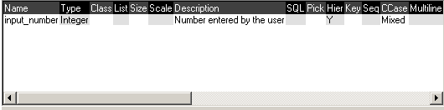
This pane displays information on the member variables within the selected class section. This data is read only.

Member Variable Definitions

Member Variables

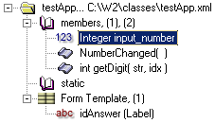
Located within, and created from the ‘class sections’, Member variables can be of type ‘String’, ‘Integer’, ‘Double’, ‘Date’, ‘Object’ & ‘List’. When left clicked, the editor pane displays all the variables attributes allowing you to edit its name, type, class, description, database options, default value, and more. Right clicking a member variable also gives you further options (i.e. to copy & paste, duplicate, delete, search, etc…).

Hierarchy Options

- Find References
Searches all the methods of the class for references to the selected member variable (See Find & Replace)
- Find Refs in Files
Searches for references to the selected member variable in multiple files (See Find in Files)
- Add Item
Add a new item to the selected member. (This option only applies to members of type ‘list’ that are declared in the static section of the class. Static lists may be built up in-line in this way)
- Open Class
Opens the member’s W2 class in a new designer window. (This only applies to members of type ‘object’ or ‘list’)
- Browse
Opens the member’s W2 class in the class browser.
- Duplicate Member
Create a copy of the member and insert it directly below the current member.
- Move Member to (non) Static
Moves the selected member to the static / non-static section of the class.
- Copy Member
Places the selected member on the clipboard so it can be pasted into other classes
- Delete Member
Permanently removes the selected member definition from the class.

Editor Pane

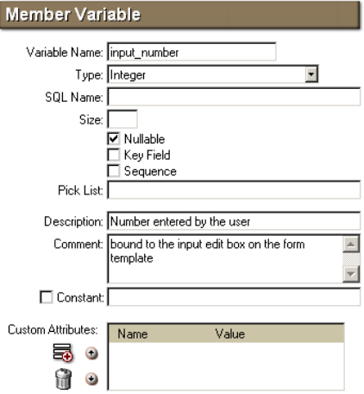
Each member has many editable attributes. All of these are displayed in the right pane when a member is selected.

- Variable Name
The name of the member variable.
- Type
Choose from one of the 6 built in types (String, Integer, Double, Date, Object & List). Both Objects and Lists can be tied down to a specific class type.
- Class
The name of a class that this member is an instance of (applicable to members of type object and list).
- SQL Name
The name of the column this member will be taken from in a database table. Leave blank to use the default name (same as the variable name), or enter a tilder (‘~’) to inform W2 NOT to take this member from the database table.
- DB Linked Table
For classes that contain comma delimited strings. Specify a table name here to store each string item in. The SQL generator found under the member section tab will create SQL code to create these tables. The global class ‘classes::core::dbList.xml’ is available specially for updating database tables with picklists. It is quite probable that if you specify a linked table you will also want to set the above SQL Name to ‘~’ to stop any data duplication.
- Size
Number of characters in the string or number of digits in a number. (Only used in database table transfers).
- Scale
Number of significant figures after the decimal point (see above)
- Nullable
The member can be set to null.
- Key Field
The member is a key field in the table.
- Sequence
The name of an Oracle Sequence used to number this member.
- MultiLine
Applicable only to Strings. If true, the string can contain carriage returns.
- Custom Attribute
When a class is to be used as a component on a form, setting this attribute to true tells the class that this member is pulled from the value of a custom attribute on the parent forms component control. When you add this component to the form, these attributes will automatically be added to it. The method ‘classes::core::global::initFormAll( aform, resize )’ should be called when you open a form with components with custom attributes so that it sets the member values for you & calls the method ‘init’ on all components afterwards (if they have one).
- Date and Time
Applicable only to date types. The date also contains a time.
- Date as String (YYYYMMDD)
Selects this date encoding. (Not used).
- Visible in Hierarchy
This member will appear in a hierarchy (only applies to list members).
- Pick List
Enter the name of a static member of type list to use as a pick list (can be in another class). The first column of the list is required to be the index referenced by the current member.
- List Content
A text file to import the list content from (filename of the form: ‘classes::client::objecttypes.txt’)
- Case
Option of ‘Mixed, Upper, Lower, & Capitalized’. Applicable only to Strings.
- Validation Template
Not really used.
- Description
A description of what this member is for. This is a way of documenting your code and is viewable from the ‘W2 Browser’.
- Comment
Extra space for comments about this member. This is not viewable from the browser.
- Constant
Tick the box and enter a value to initialise the member to. A constant can be changed at run time.
- Custom Attributes
Here you can add a list of custom Attributes that are assigned to the member variables definition. These can be retrieved using the GetAttr( attribute_name ) method of the memberdef class. You can add and remove entries from the custom attribute list using the add & remove buttons to the left of the list.

Member Function Definitions

Member Functions

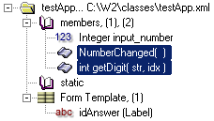
Member Functions (also called Methods), located within (and created from) the ‘class sections’, are where the real coding takes place. When selected, the editing pane displays the source editor with the associated method source displayed within. Right clicking a method in the hierarchy gives the same functionality as for member variables.

Hierarchy Options

- Edit Parameters
Brings up the parameter editing dialog box to edit the parameters for the selected method.
- Find References
Searches all the methods of the class for references to the selected method (See Find & Replace)
- Find Refs in Files
Searches for references to the selected member variable in multiple files (See Find in Files)
- Duplicate Method
Create a copy of the method and insert it directly below the current method.
- Move Method to (non) Static
Moves the selected method to the static / non-static section of the class.
- Copy Method
Places the selected method on the clipboard so it can be pasted into other classes.
- Delete Method
Permanently removes the selected method from the class.

Editor Pane

The right hand pane for the selected method definition is a W2 script editor (used for developing your application code for that method).

Above the actual method script code is the script editor’s tool bar. From here you can set the method’s name and parameters as well as to do text searches in the script code, etc:

- Method Name
Enter the name of the method in the edit box labelled ‘Method Name’.
- Parameters
Click the Parameters label or symbol to open the Parameter Editing Dialog Box.
- Undo / Redo (Ctrl+Z / Ctrl+A)
Undo and Redo current typing in the source editor below.
- Search Box (F3)
Enter a search string into this box and press <- or -> to find the next or previous instance of the string in the current method, or <X or X> to find the instance in any method in the current class section. Alternatively, enter the search string and press enter to open the ‘Find & Replace’ Dialog box (giving you a more powerful search)
- Parse (F7 / F8 spell check)
Left Click ‘parse’ to check the validity of the code in the script editor window below. Right click to perform a spell check on all strings in the method (only works if you have MS Word installed).

Method Editor

Method Editor

The method editor in its simplest form works like a simple text editor (like notepad). Simple select the method (member function) you wish to edit in the lass hierarchy and edit the method script in the method editor pane on the right. However, there are many more features both working behind the scenes and many more features that can be activated manually:

- Syntax Highlighting
Code in the method editor window is coloured to enhance certain features of the code:
- Reserved keyword appear blue
- Strings appear peach
- Comments appear Green
- Chars appear light blue

- Right Click Options
When you click the right mouse button over some source code, a context sensitive menu appears under the mouse cursor from which you can get information about what you clicked on and issue commands based on the same.
- Copy – Copy text around cursor or if selected, all selected text under cursor.
- Paste – Paste text from clipboard into source.
- <variable declaration> – If the source under the cursor is based upon a variable then the variables declaration is displayed here. Select the declaration in the menu to be taken directly to its declaration in the source code.
- Open Class/Method/Member – If the variable/method/code under the cursor refers to a class/method or member in the same or another class, use this option to jump straight to it. (Shortcut F12)
- Browse Class/Method/Member – As above, but instead of jumping to the item, the class browser is launched and displays the selected item in its class hierarchical context. (Shortcut F1)
- Search For ??? – Searches of the text under the cursor in the current classes methods.
- Search For ??? in Files – As above, but searches in other class files too.
- Context Tip – Displays a context tip for the source code under the caret (Shortcut F4)

- Function keys
The following function keys are short cuts available while you are in the source editor:
- F1 – Browse (See Browse Class/Method/Member under right click options)
- F2 – List Methods & Members (Drops down a list of methods and members that can be used in the current context)
- F3 – Search and Replace (Opens the Search & Replace Dialog box)
- F4 – Context Tip (See Context Tip under right click options)
- F5 – Run Class (Runs the current class)
- F6 – Match Bracket (Jumps the text caret to the bracket matching the one under the text caret)
- F7 – Parse Method (Perform a syntax check of the current method)
- F8 – Spell Check Method (If Microsoft Word is installed on your machine, this will spell check all the strings in quotes in the current method)
- F12 – Open class/method/member (See Open Class/Method/Member under right click options)

- Auto Correct (as you type…)
If you type in the string ‘ccg’ followed by a ‘#’, the script editor changes the string to read ‘classes::core::global’. This is an auto corrected string and a customisable list of these strings in available from the ‘Options / Configuration Options…’ menu.

Extra information on using the script editor can be found in the ‘W2 How To’ Document.

Form Template

Form Template

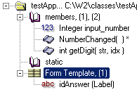
A form class ha s its form attached to the Form Template section in the class hierarchy. Selecting the form template causes the right hand edit pane to show an editable version of the classes form. Also, within the form template hierarchy section is a list of the ‘named’ controls that reside in the form template. Clicking on these will select the associated control in the edit pane. You also have extra options by right clicking these named controls.

Editor Pane

A Class’s form is built up from a base grid with controls and child-grids placed within its cells. You can select a cell by clicking on it with the mouse. Information about the grid cell is displayed in a docked toolbar to the right. If the cell contains a control, the controls information is displayed in a floating Control toolbar.

You can select more than one cell at a time by clicking and dragging the cursor over multiple cells or by clicking one at a time with the ‘Ctrl’ key held down.

You can move a control from one cell to another by clicking on the source control with the shift key held down and dragging it to the destination cell and releasing. (Holding down both the shift and ctrl keys together while dragging creates a copy of the control).

Form Template Toolbar

At the top of the form template pane is a toolbar. The functionality of each button is as follows:

Button | Action
 | Menu - Drop down menu to Copy the entire form, Insert a parent grid about the selected grid, delete the parent grid, or delete the entire form
 | Up a level - Selects the grid the selected cell is a member of.
 | Undo - Undoes the last operation.
 | Redo - Redoes the last undone operation.
 | Insert Control - Drop down list of control types. Select a control to insert it into the selected cell in the form grid.
 | Insert child-grid - Insert a child grid into the currently selected cell.
 | Merge Cells - Merges a rectangular area of selected cells into one cell.
 | Split Cells - Supposed to split merged cells, but you would be better right clicking the merged cells and using the split cells from there since the toolbar button tends to not function correctly.
 | Insert Row Before - Inserts a row of cells into the current grid before the selected row.
 | Insert Row After - Inserts a row of cells into the current grid after the selected row.
 | Insert Column Before - Inserts a column of cells into the current grid before the selected column.
 | Insert Column After - Inserts a column of cells into the current grid after the selected column.
 | Hide/Show Grid Lines - Hides / Shows the grid lines in the grid editor pane.
 | Hide/Show Component contents - Hides / Shows the contents of a component (if known at design time)
 | Hide/Show Floating Control Toolbar - Hides / Shows the attributes toolbar for the selected control.
 | Set Root Grid - Inserts a root grid (choose number or rows & columns).
 | Delete Cell Contents - Removes all controls and child grids from the selected cells.

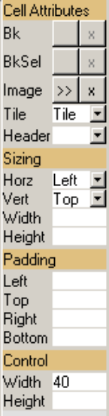Cell Attributes Docked Toolbar

This toolbar is located on the right hand side of the grid template pane. It specifies the visual formatting of the currently selected cells.

It is split into these categories:

Cell Attributes
- Bk - (Background Colour of Cell). Press the first button to choose a colour, or the button marked ‘x’ to clear the colour.
- BkSel - (Background Colour of Cell when Selected). Press the first button to choose a colour, or the button marked ‘x’ to clear the colour.
- Image - (Background Image/bitmap of Cell). Click ‘>>’ to bring up a file requester dialog to select a bitmap, or ‘x’ to clear the bitmap selection.
- Tile - Tells W2 how to render the background image in the cell:
  - Tile = Tile bitmap horizontally & vertically.
  - Stretch = Stretch horizontally & vertically to fit cell.
  - Single = Don’t Tile or stretch.
  - Pad Tile = Tile H & V, but keep left, right, top & bottom edges intact as far as the padding of the cell.
  - X_PadT = As Pad Tile, but Stretch Vertically.
  - Y_PadT = As Pad Tile, but Stretch Horizontally
- Header - Set to ‘Yes’ within a ‘listbox’ control cell to instruct that row to be drawn once only at the top of the grid.

Sizing
- Horz - Determines how the control within a cell is positioned and sized horizontally:
  - Left - Aligns the control to the left.
  - Center - Aligns the control to the centre.
  - Right - Aligns the control to the right.
  - Cell Width - Stretches the control to fit the cell horizontally (but the cell will not resize to fit the form.
  - Stretch - Stretches the control to fit the cell horizontally, and instructs the cell to resize to fit the form.
- Vert - Determines how the control within a cell is positioned and sized vertically:
  - Top - Aligns the control to the top.
  - Center - Aligns the control to the centre.
  - Bottom - Aligns the control to the bottom.
  - Cell Height - Stretches the control to fit the cell vertically (but the cell will not resize to fit the form.
  - Stretch - Stretches the control to fit the cell vertically, and instructs the cell to resize to fit the form.
- Width - Width of the cell in pixels. (Only affects the control if the control is set to scale with the cell).
- Height - Height of the cell in pixels. (See above).

Padding
- Left - Number of pixels between the left edge of the cell and the left edge of the control in the cell.
- Top - Number of pixels between the top edge of the cell and the top edge of the control in the cell.
- Right - Number of pixels between the right edge of the cell and the right edge of the control in the cell.
- Bottom - Number of pixels between the bottom edge of the cell and the bottom of the control in the cell.

Control
- Width - The minimum width of the control in pixels within the cell (the control will get larger than this if it is set to stretch with the cell).
- Height - The minimum height of the control in pixels within the cell (see above).

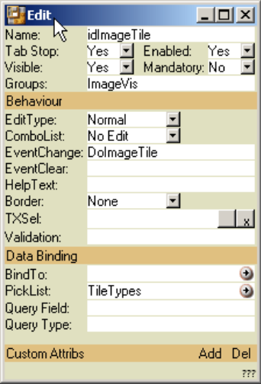
Control Edit Floating Toolbar

This floating toolbar contains all of the attributes specific to the selected control in the form template editor. The attributes shown are different depending on the type of control that is selected. Attributes common to nearly all controls are these:

- Name - The name you want to refer to the control by.
- Tab Stop - Set to yes if you want this control to be visited by the caret when the user pressed tab key.
- Enabled - Set to yes to initiate this form in the enabled state. In the disabled state you can’t enter data into the control.
- Visible - The control is hidden from view if not visible. Space is not reserved for the control so the form may resize when this is changed.
- Mandatory - Yes if this is a mandatory input field
- Groups - A comma delimited list of visible-groups this control belongs to.
- HelpText - A short help tip for this control.
- Border - The type of visible border placed around the control.
- BindTo - The name of a member that will be bound to the data within this control.
- OnClick - There are many variations on this attribute corresponding to different events triggered by clicking with the mouse or the altering of the data within a control. The attribute entered is the name of a method within the class that is to be executed when the event occurs. (Note: Clicking on the label next to the attribute will take you to the definition of the named method in the class, or if it does not yet exist, will create it for you)

These are some common attributes shared by many of the available control types. For detailed descriptions of all control attributes please refer to ‘Appendix: Control Edit Floating Toolbar’ on page 27 of this manual.

Form Menu

Form Menu

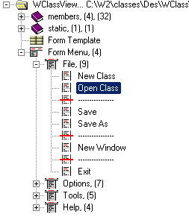
The Form Menu is located at the bottom of the class hierarchy pane on the left hand side of the designer window. It is used to edit a drop down menu that will appear at the top of a form (assuming it is not within a component or MultiPane). A menu has a root structure called the Menu Root. You must create this to hold the menu headings, which in turn hold the menu items and menu separators. To initially create a menu root, right click the very top item in the class hierarchy (with the little yellow folder icon) and select ‘New Form Menu’. The new menu root will appear towards the bottom of the hierarchy.

Menu Root

The menu root is a container for a number of menu headings. Right clicking the menu root will give you the options to add a menu Heading or delete the entire menu (& menu root).

Menu Heading

A good example of a typical first menu heading is ‘File’ followed by the menu heading ‘Edit’. Right clicking the menu root and choosing ‘New Menu Heading’ creates a menu heading.

To set the name of a menu heading to ‘File’, ‘Edit’ or any other text string just select the heading to be edited in the hierarchy and change the text in the edit box labelled ‘Caption’. (The caption text will default to ‘New Menu Header’, just delete this and replace with your desired caption).

Menu items or separators may be added to the menu heading by right clicking the new/existing menu heading and selecting the appropriate ‘New …’ option.

Menu Items

To insert a menu item, right click the menu header to insert it under, right click and choose ‘add menu item’. Drag the new item up or down to place it at the desired location if required.

A menu item has three attributes associated with it:

- Caption - A text string that will appear under the menu heading that the user will select to choose this option.
- Name - The name of this menu item. If you use the default onMenu even rather than choosing a specific OnClick method to call then this ‘name’ will be passed to the onMenu method as a parameter so you can tell which menu item has been selected.
- On Click - Enter the name of a method to be called if this menu item is selected at run time. If no member is supplied then the default onMenu method is called with this menu item’s ‘Name’ attribute passed to it as the first parameter.

Menu Separator

To split up the items in a drop down menu, you can insert menu separators between the menu items under a menu header. To insert a menu separator, right click the menu header to insert the separator under, right click and choose ‘add separator’. Drag the new separator up or down to place it at the desired location.

Hierarchy Display

Hierarchy Display

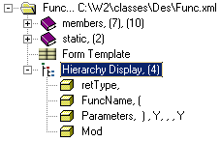
A hierarchy component is a visible rendering of a recursive class structure. Each instance of a class appears at a row in the hierarchy control beginning with a small icon and followed by a line of text. The text defaults to the values of every member of the class appended one after the other. To alter what is displayed you create a ‘Hierarchy Display’ in the class’s class hierarchy.

To initially create a hierarchy display, right click the very top item in the class hierarchy (the class definition with the little yellow folder icon) and select ‘New Hierarchy Display List’. The new hierarchy display will appear towards the bottom of the class hierarchy.

Every member of the class you would like to appear next to its icon in a hierarchy must be added as a separate hierarchy to the hierarchy display list. There are various options to set how the text will be displayed.

Display Items

To add a display item to a hierarchy display list, Right-click the hierarchy display and select ‘New Display Item’. The right hand pane of the designer will show a number of attributes that affect what the display item actually represents:

- Member Name - The name of a member in the class, the contents of which is to be placed next to the class’s icon assuming it is in a hierarchy. The first hierarchy display item is displayed at the left next to the icon; all subsequent ones are displayed concatenated onto the string to the right.
- Suffix - A text string (or character) to be appended onto the member value before any more members are appended.
- Date Format - Date formatting string (assuming the member is of type date).
- Time Format - Time formatting string (assuming the member is of type date).
- Show Item Caption - Tick to force the display of the member’s caption.
- List of Items - Tick if this member is a list and you want to display the member’s contents here.
- Between - Assuming the ‘List of Items’ is ticked, this string is placed between each of the lists items.
- Always Show Suffix - If not ticked and a member is empty the suffix is not drawn.

Designer Menu Reference

Designer Menu

The main menu provides access to many of the same functions available from the hierarchy toolbar. However, there are a few other options available not otherwise accessible from anywhere else. We shall now go over each of the menus giving an explanation of what each one is for:

- File

The file menu is for the general loading & saving of classes, and for Opening and Closing designer windows.

- New Class - Flushes the open class (with option to save) creating a clean designer window.
- Open Class - Prompts you for a class file to open (option to save already open class).
- Save - Saves the open class under the same filename as it was opened or last saved as.
- Save As - Saves the open class under a new name prompted from the user.
- New Window - Opens a fresh designer window (leaving the current window open).
- Close - Closes just the current designer window (with prompt to save).
- Close All - Close all open designer windows (with prompts to save each).
- Close IDE - As above, plus shut down the IDE (remove icon from taskbar).

- Edit

The edit menu is used for searching within methods, classes & projects as well as parsing the loaded class.

- Goto Line - Takes you to a user prompted line number in the currently open method.
- Find / Replace - Opens the Find & Replace Dialog (Searches in all methods in the current class)
- Find in Files - Opens the Find in Files Window.
- Find Projects - Searches for all project files that have the current class in their project tree.
- Parse All - Do a syntax check on all members and methods in the class.

- Options

The options menu allows for the customisation of the W2 designer to suit your needs & computer spec.

- Run Class… - Execute the current class file.
- Run Console… - Opens the XRunApp Console.
- Run Class from HTTP Server?
- When ticked, any classes ‘run’ from within the designer will be run on the web server. Otherwise they will be run locally.
- Synchronise Running Classes?
- When ticked, modifications to local classes take affect at runtime. Modifications to forms do not occur until the forms are closed and re-opened.
- Active Method Tips
- Cause help tips to appear under methods as you type in the source editor.
- Adv. Method List
- The F2 function in the source editor can be set to advanced mode if you prefer its new improved functionality.
- Parse on Save
- When active, classes are parsed before you can save them. If they include syntactic errors then you must correct them before you can proceed.
- Method Version Tagging
- Activate this option to tag all modified methods with a user name & time stamp.
- Show Components
- Causes components & multipanes to show their contents in the template editor.
- Configuration Options…
- Opens the designers configuration options dialog box.

- Tools

The tools menu is used to access other useful developer tools.

- Utilities - (Redundant) Outputting table SQL for the loaded class.
- Get Trigger SQL - (Redundant) Outputting trigger SQL for the loaded class.
- Map Editor - Opens the Map Editor
- RTF Editor - Opens the RTF Template Editor
- Calc Builder - Opens the Calc Builder
- Internet Explorer - Opens Internet Explorer

- Source Safe

If you have Source Safe installed, then you can use this menu to check out & in your files directly. Set up your source safe ini string from the ‘Options\Configure Options…’ Menu.

- Get Latest - Replaces the currently loaded class with the most up-to-date version.
- Check Out - As above, but also checks the file out to you.
- Check In - Checks the current class into source safe (making your copy read only)
- Check In (Keep Out)
- As above, but keeps the file checked out to you afterwards.
- Undo Check Out
- Undoes your checkout, replacing your local copy with the previous version.

- Help

To get help, choose from the following help options:

- Short Cuts - Displays a help box containing short cut key presses.
- W2 Script - Opens the W2 Script help in Internet Explorer.
- Forms - As above but for ‘forms’
- About W2 - Opens the W2 About Box with current version information.

W2 Browser (Overview)

The Browser displays classes in a hierarchy tree, listing methods & members, form controls and w2 built-ins. Classes are displayed recursively and can be opened to your desired depth of interest. When an object is browsed from the designer, the browse path will be opened for you. The Browser is also used as a W2 class help system showing the available built in classes & methods.

Using the Browser

Use in the same way as the Class Designer’s Hierarchy View. Expand members & methods by clicking on the little box to the left of any item.

Right click a member or method for options to jump directly to code, or double click for default jump to code.

Keep the browser on top when moving to other windows by single clicking the pushpin icon in the lower right of the class browser window. (Click again to unpin).

The current position in the hierarchy is displayed in textual form at the base of the browser window. You can copy and paste this text into the source editor.

The Browser Help System

All the major built in W2 classes are browseable in the class browser. To open the main W2 script help window either select ‘Help’ from the Taskbar Designer icon, or type help <enter> into the lower browser edit box.

Searching in the Browser Help System

The edit box at the bottom of the browser window not only displays the current location in the hierarchy, it also acts as a search text box.

It can take strings of the following kind:

- Help Brings up all the W2 script help classes
- <class name> Opens a specific class (i.e. string)
- ?<member> Finds all instances of the specified method or member in built in W2 classes.
- ?*<member> Finds all instances of the specified sub-string in all methods and members of the built in W2 classes.

W2 Project (Overview)
A Project collects together classes you require for a specific programming task. The project is again hierarchical so you can place one class as the child of another, just as it would be when the classes in question are executing. Project provide you with quick access to the classes you are working on, allow other programmers to quickly approach your code with a better overall view, and add extra functionality to the Browser and form template view.

Functionality provided by Projects:
- Browser tracing of parent classes – When a project is set up, the class browser is able to use the extra information to give methods like ‘getparent’ the correct return type. (This information is given by the hierarchical structure of the project, and which classes are positioned above which other classes).

- Component & MultiPane overriding – A child class in the project can be assigned a control name (of a component or multipane from the parent class). When the parent class is opened in a designer window, the form template will display the overridden classes in the components & multipanes.

- Quick access to Classes – Classes in a project file may in reality be spread all over your hard drive, but they are collected together in the project. Double clicking a project class opens it directly in a W2 Designer window.

Projects can also be generated from an executing W2 application using W2 Wrapper, quickly capturing a snap shot of the open windows.

Manipulating the class structure within a project

To add a class file to the project hierarchy, right click on the root node or on any existing class in the project and select ‘add child class’. From the open File dialog box choose a class to add. You can also cut, copy & paste classes within the hierarchy to aid in manipulating large or repetitive structures.

To document a class in the project, select the class in the hierarchy and enter notes into the lowest edit box in the project window. If it is not visible then you can make it visible by clicking on the ‘Description / Notes’ button to toggle it’s visibility.

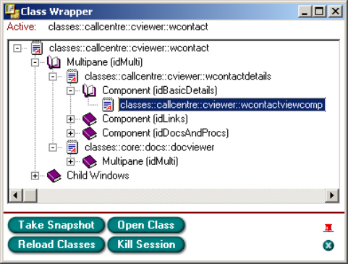
W2 Wrapper (Overview)

W2 Wrapper takes snapshots of running code, letting you see what classes are used where and allowing you to quickly open them in the designer. Projects can also be generated from a running W2 application cutting down pre-development time and the tricky task of creating complete, accurate projects.

Any class executed from the designer will already be running ‘wrapped’. You can only open a Class Wrapper window for applications that have been ‘wrapped’.

With the current application wrapped and the designer IDE open, select ‘W2 Wrapper’ from the W2 taskbar Icon. The class wrapper will open in a small window. If no wrapped applications are running then the ‘W2 Wrapper’ option will not appear on the taskbar menu.

To wrap an unwrapped executing application, open the W2 consol from the running application, change the path to ‘http://localhost/classes/’ and enter ‘classes::des::runWrapped::go();’. Now click ‘Exec’. The application is now ‘wrapped’.

The four buttons on the wrapper window do the following:

- Take Snapshot
Creates a hierarchical snapshot of the last window to have the focus in the attached W2 Application. This snapshot includes components & multipanes as well as child windows of the active window. The classes in the hierarchy can be double clicked to open them in the class designer, or right clicked to give options to debug and create a project.
- Open Class
Opens the active window in the attached W2 application in a W2 designer window.
- Reload Classes
Invalidates any classes cached by XRunApp so that updates classes will be reloaded when needed and any changes will be take affect.
- Kill Session
Closes all the windows in the attached W2 application & closes the wrapper.

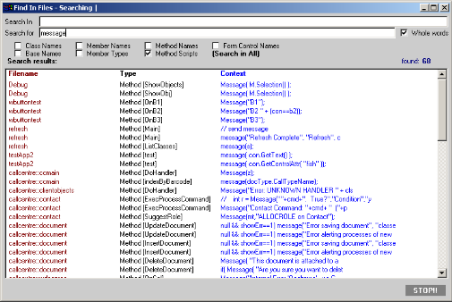
W2 Find in Files (Overview)

Find in Files is a W2 class specific search tool for finding textual occurrences in class, method, member & control names as well as the actual W2 code itself. Once a search has been done you can jump directly to the occurrences in the W2 Designer with a simple double click of the mouse.

- Search In
Class path to use as the root of the search. Enter a string like ‘classes::client’ or ‘c:\w2\classes\client’.
- Search For
Text string to search for in the files.
- Whole words
When ticked, only files that contain the search string as whole words (not surrounded by any other characters or invalid symbols) will be returned by the search.
- Class Names
Return classes whose Class Name matches the search string.
- Base Names
Return classes whose Base Class Name matches the search string.
- Member Names
Return all members whose names match the search string.
- Member Types
Return all members whose object/list types match the search string.
- Method Names
Return all methods whose names match the search string.
- Method Scripts
Return all instances of the search string within the methods scripts of classes in the search path.
- Form Control Names
Return all controls whose names match the search string.
- (Search in All)
Clicking this ticks all the above check boxes (clicking again un-ticks them all).
- Search Results:
Lists all the found classes and the area within that matched the search string. Double click to open the class at the relevant point, or right click for a more detailed view of the found instance.
- Find
Click to initiate the search, Click again to abort.

Appendix: Control Edit Floating Toolbar

This floating toolbar contains all of the attributes specific to the selected control in a cell. The attributes shown are different depending on the type of control that is selected. Attributes common to nearly all controls are these:

- Name - The name you want to refer to the control by.
- Tab Stop - Set to yes if you want this control to be visited by the caret when the user pressed tab key.
- Enabled - Set to yes to initiate this form in the enabled state. In the disabled state you can’t enter data into the control.
- Visible - The control is hidden from view if not visible. Space is not reserved for the control so the form may resize when this is changed.
- Mandatory - Yes if this is a mandatory input field
- Groups - A comma delimited list of visible-groups this control belongs to.
- HelpText - A short help tip for this control.
- Border - The type of visible border placed around the control.
- BindTo - The name of a member that will be bound to the data within this control.
- OnClick - There are many variations on this attribute corresponding to different events triggered by clicking with the mouse or the altering of the data within a control. The attribute entered is the name of a method within the class that is to be executed when the event occurs. (Note: Clicking on the label next to the attribute will take you to the definition of the named method in the class, or if it does not yet exist, will create it for you)

These are the common attributes. More specific ones will be covered in the preceding sections on specific controls.

Grid

A Grid is not actually a control, it is a holder for controls and is inserted as the root to a form and as child grids within the root grid. It does however still have attributes that may be set to affect its visual appearance.

Display
- BkColor - The background colour of the grid.
- BkImage - A bitmap to use as the background of the grid.
- Tiling - Defines how BkImage will be rendered (Tiled, Stretched or as a Single Image).

Cell Padding
- Left, Right, Top, Bottom - Distance in pixels between ‘every’ cell within the grid.

Label

A label is used for two purposes, firstly as a simple text label on a form (not a fixed string, but modifiable at run-time if the programmer wishes), or as a clickable text button.

Display
- Text - The text to be displayed in the edit box.
- Font - (font, colour, size & style) Used to set the font of the text displayed.

Text Effects
- Type - Shadow type: Offset = copy of text offset from original, Thick = copy of text drag-copied from original.
- X - Distance horizontally in pixels of the shadow from the original.
- Y - Distance vertically in pixels of the shadow from the original.
- Shadow - Colour of the shadow.
- TL - Top Left colouring of original text.
- BR - Bottom Right colouring of original text.

Data Binding
- BindTo - A member name to bind this label’s ‘text’ field to.
- For plain labels:
Enter the name of a member in this box. The label text will be kept in sync with the contents of the member variable. (You may use ‘.’ to traverse an object hierarchy)
- For labels within a listbox control
Enter the name of the member within the object bound to by the listbox control. If the member has a picklist associated then you may follow the member name by a period and the name of a member within the picklist.
- Format - Date formatting for the bound member (i.e. “dy d month yy”)
- OnClick - The name of the method to be called if this label is clicked on with the mouse. If this is set to anything then the label text becomes a button.
- OnRClick - The name of the method to call on a right-click.
- Param - This is simply an attribute of a label that can contain any text the designer wishes and is not actually passed as a parameter but must be retrieved using getControlAttr(“param”).

List Options
- Header - Performs the same operation as the cell attribute ‘header’ field. Set this to 1 to state this is the header row of a listbox and should not be repeated over and over for each row of the list.
- TXSel - The colour of the ‘text’ when the row is selected.
- BKSel - The colour of the background when the row is selected.
- TXField - Name of a field in the bound list that holds the colour for this text label. (The field must be of type integer, hex -> ‘rrggbb’)
- BKField - As above, but for the background colour.

Image

An Image control is a rectangular region containing a single bitmap image. The image is always displayed at a zoom ratio of 1:1 and so can not be scaled. If the containing cell’s sizing is set to stretch then the image is tiled over and over, but in this case too will not scale. The cell’s padding also has no affect on the rendering of the image. If the image contains transparency information then those areas will indeed appear transparent and it is perfectly valid for the containing cell to also have a background image (thus you will have an image upon an image).

- Image - Click the button labelled ‘…’ to locate a bitmap image file to display in the control.
- OnClick - The name of the method to be called if this image is clicked on with the mouse.
- OnRightClick - The name of the method to be called if this image is clicked with the right mouse button.

Edit

The edit control has quite a variety of features. It can be a simple text entry box, but can also be a drop down selection box, or a multi-lined text-editing box with word wrap & a scroll bar.

Behaviour
- EditType - Choose the type of data the edit box is to hold. (Normal = plain text with no line breaks, Multiline = as normal with line breaks, Numeric = Numeric characters only, etc).
- ComboList - Drop down combo-list options. (None = no drop down, Edit+list = text edit box with drop down selection, No Edit = Non-editable text box with drop down choice list.)
- EventChange - Name of a method to call when the text within the edit box is changed.
- Border - The style of border around the edit box.
- TXSel - The colour the text will take on when selected if it within a listbox control.

Data Binding
- BindTo - A member name to bind this label’s ‘text’ field to.
- For plain editboxes:
Enter the name of a member in this box. The editbox text will be kept in sync with the contents of the member variable. (You may use ‘.’ to traverse an object hierarchy)
- For editboxes within a listbox control
Enter the name of the member within the object bound to by the listbox control. If the member has a picklist associated then you may follow the member name by a period and the name of a member within the picklist.
- PickList - The name of a member variable (of type list) to be used as a picklist for a combo list edit box.
- Query Field - Does nothing directly. Used to hold query field data.
- Query Type - As above.

Radio

Radio buttons must be bound to a member variable to function correctly. Bind linked radio buttons to the same variable and choose different values of the ‘value’ attribute for each. A radio button is ‘ticked’ when the bound variable equals the radio buttons ‘value’ attribute value.

Appearance

- Image - A bitmap to be used instead of the standard windows radio button icon. The bitmap must be 3x wide and 2y high (comprising 6 images of size x by y). The top three images are of ‘unticked box’, ‘unticked selected box’, & ‘unticked disabled box’. The bottom three images must be of the format ‘ticked box’, ‘ticked selected box’, & ‘ticked disabled box’. When left blank the default radio button control icon is used.
Behaviour
- OnClick - Name of a method to call when the radio button is clicked.
Data Binding
- Bind To - Name of a member variable to bind this radio button group to.
- Value - The value the bound variable is set to if this radio button is checked.
- Group - You can specify a group the radio button belongs to. When not binding to a variable, you can use this to keep radio buttons grouped and check whether one is selected using the radioControlName.getState() method.

Checkbox

Tickable boxes that can have two or three states (e.g. Yes/No, True/False/Maybe, 0/1/2). Clicking on a checkbox cycles it through its states.

- Image - See the Radio Box Control above for an example of how this bitmap should be formatted. For a three state checkbox, the bitmap must include 9 images (3x3 images). The bottom row represents the ‘Maybe’ state. When left blank the default checkbox button control icon is used.
- Steps - Choose ‘2’ (yes/no) or ‘3’ (yes/no/maybe) steps.
- Style - The weighting of the text next to the checkboxes. Choose between Normal & Bold.

Behaviour
- OnClick - Name of a method to call when the checkbox is clicked.

Data Binding
- Bind To - Name of a member variable to bind this checkbox to.
- Value 0 - The value the bound variable is set to if this radio button is in state ‘No’.
- Value 1 - The value the bound variable is set to if this radio button is in state ‘Yes’.
- Value 2 - The value the bound variable is set to if this radio button is in state ‘Maybe’.

PickQuery

A PickQuery is a control that allows the selection of any number of objects from a list.

Style
- Border - The border style surrounding the pickquery control.
- Orientation - ‘Delimited Text List’ = the selected objects are shown as a horizontal list of names delimited by commas. ‘Vertical List’ = the selected objects are shown as a vertical list of names (each on a separate line).
- Show Value - Unknown.
Behaviour
- BindTo - Name of a member of type string. The key field of each of the selected objects will be appended into this string variable delimited by commas.
- PickList - Name of a member variable (which is a list of objects). The first member of the object will be used as the key field (see BindTo) and the second member will be used as the title of each object in the displayed picklist.
- Query Field - Does nothing directly. Used to hold query field data.
- Query Type - As above
- Event Change - Method Name to call when the user modified which objects are selected.

ListBox

A listbox is an editable or non-editable list of records in a customisable repeating visible form.

Data Binding
- BindList - The name of a member variable of type List that contains the list of objects to be viewed in the ListBox.
- KeyToField - Unknown.

List Events
- SelectChange - Name of the method to call is the selection changes from one record in the list to another.
- ClearSelect - The name of a method to call if the selection becomes empty.
- PreSelectChange - The name of a method to call after the user clicks to change to a new record, but before that control actually becomes the selected record.
- DoubleClick - The name of a method to call if the user double clicks a record.
- SingleClick - The name of a method to call if the user single clicks a record.
- RightClick - The name of a method to call if the user right clicks a record.
- DropObjects - Apparently does nothing at time of writing.

Appearance
- Multi Select - If set to ‘yes’, the user can select more than one record in the list at once, otherwise only one record may be in the selected state at a time.
- Use Grid - If set to ‘yes’, you are required to place labels and edit boxes within the listbox grid in the editor which are ‘bound’ to member of the BindList. Otherwise W2 will create a quick grid for you based upon all of the members of the BindList.
- FixSize - If set to ‘yes’, the listbox will have a height fixed to the size of all the records in the list stacked one on top of the other. All records will therefore be visible on the form at once. Otherwise, the height of the control will be equal to whatever you instruct it to be, and a vertical scroll bar will allow you to scroll up and down the records.
- Border - The border style of the control.

Cell Padding
- Left, Top, Right, Bottom - Padding in pixels around each cell in the listbox grid (measured in pixels). This does not override any existing cell padding in the cells so for it to work you must make sure all relevant padding is set to 0.

Row Margins
- Left, Top, Right, Bottom – To be done.

Hierarchy

This control must be bound to an object that contains a list of objects to be displayed as root members of a hierarchy within this hierarchy component. Any members within these objects that are marked ‘Visible in Hierarchy’ will also be visible as children of their owning objects (and so it continues). See the ‘Hierarchy Display List’ needed to customize the display of objects in a hierarchy.

- BindTo - The name of a member within the class. This must be of type object, and the class type of the object must contain a list member with the ‘visible in hierarchy’ check box checked (in its member definition).

Component

The component control is a rectangular area on a form that contains another form in a parent/child style relationship. The child form may be changed at run-time using W2 script or set at design time to a specific form class.

- Scroll - If set to ‘1’, the size of the control is restricted to the size specified in the cell width & height. Scroll bars will be displayed if the child form is larger than the size of the containing cell. If scroll is not set to ‘1’, the parent cell will size to fit the contained form.
- Class Name - The class name (inc path in ‘::’ format) of the form to display in the control.

When a class name is entered and the <enter> key pressed (or the LOAD button pressed below), and custom attributes specified in that class will be placed in the custom attribute section below. (See Custom Attributes)

MultiPane

Like a component, but can contain multiple child forms that may be arranged one in front of the other. A child cannot be assigned at design time.

SizeBar

Place a SizeBar control in a cell to allow the user to redistribute the area to the left and right (or above and below) of the SizeBar at run-time. For a horizontal bar you will find it useful to give the control a height of at least 4 pixels and a width of ‘fit to cell’. Use appropriate values for a vertical cell based on this. It is normal for the SizeBar to run the whole length of the area to be resizable so you may need to merge cells to place the SizeBar in place.

- Run Horizontal - No = The SizeBar runs vertically and is used to distribute the form area to the left and right of the control. Yes = The SizeBar runs horizontally and is used to distribute the form are above and below the control.
- Stretch Other Way - Unknown control property, keep set to ‘No’.

MapEditor

This is the Contact Manager Map Editor control. A description for this control is not provided here as it is too specialised. It will be inserted if there is enough demand.

SourceEditor

This is the W2 Source Code Editor. A description for this control is not provided here as it is too specialised. It will be inserted if there is enough demand.

RTFEditor

This control is a text-editing box (or more specifically, A Rich text editing control). It has the functionality to load, view and allow the editing of formatted text (colour, font typeface, size, bullets, etc).

- Toolbar - 1 = Show the text formatting toolbar across the top of the control.
- SB - 1 = Show the Status Bar at the bottom of the control (displaying Page number, etc).
- Ruler - 1 = Show the Ruler at the top of the control under the Toolbar.
- TextOnly - Leave this blank.
- ReadOnly - 1 = No user editing, 0 = User can edit the control contents.
- Horizontal Scroll - Defaults to ‘1’, showing the scroll bar. Enter 0 to hide the bar.
- Vertical Scroll - Defaults to ‘1’, showing the scroll bar. Enter 0 to hide the bar.
- Font - Name of a font to use as the default font.
- Font Size - Size in points of the default font.
- onChange - Name of a method to call if the text is changed within the Rich Text Edit Control.

ImageViewer

A tiff manipulation and viewing control with functionality to add and edit related notes. A description for this control is not provided here as it is too specialised. It will be inserted if there is enough demand

Custom Attributes

At the bottom of the floating control attribute toolbar is a section titled ‘Custom Attribs’. You are able to create your own custom attributes and enter initiation values for each for every control in a form. This is especially useful for component controls as there is extra functionality for these controls. When the class name attribute is entered and the <enter> key pressed (on LOAD is clicked) any string members of that class (with the ‘Custom Attribute’ set in its member definition) will be added to the custom attribute section of the component. The value of the attributes may then be entered to suit that control. Note that default values for the custom attributes may also be added to the member definition by using the ‘Constant’ check and edit box.

